Taram Zafar

Frontend Development Project

Internify task 2:

Description:
Create a pricing/product section with 3–4 cards, and make it functional and interactive rather than static:
- Each card should include an image/icon, title, description, price, feature list, and a CTA button
- Add a Monthly/Yearly toggle switch (using JavaScript) that changes the price shown on each card dynamically
- Add a category filter (using buttons like "All / Basic / Premium") that filters which cards are visible — even if it's dummy product cards, not pricing, this filter logic should work using JavaScript
- Apply hover animations (card lift, shadow, or border glow) using CSS transitions
Additional Requirements to make it more interesting:
- Highlight one card as "Most Popular" with a distinct badge/style
- Make the layout fully responsive using CSS Grid or Flexbox
- Add at least one micro-interaction (e.g., button click animation, active state on filter buttons)
Learning Outcome: JavaScript DOM manipulation, dynamic content updates, event listeners, and building interactive UI components — not just static styling.
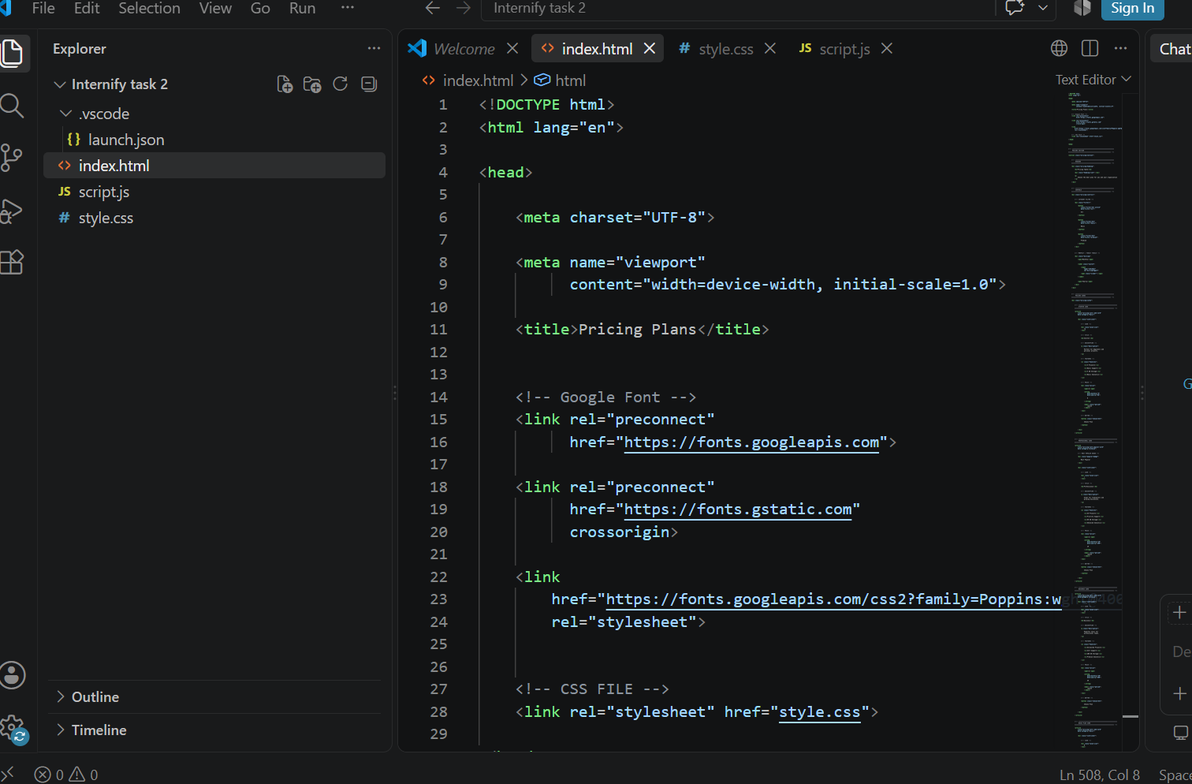

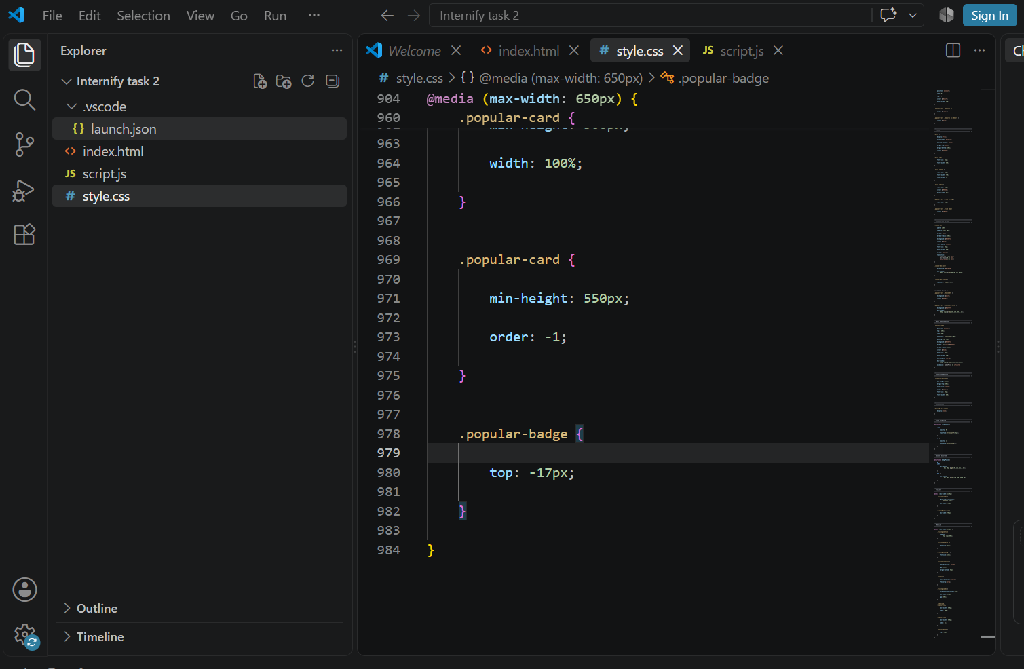
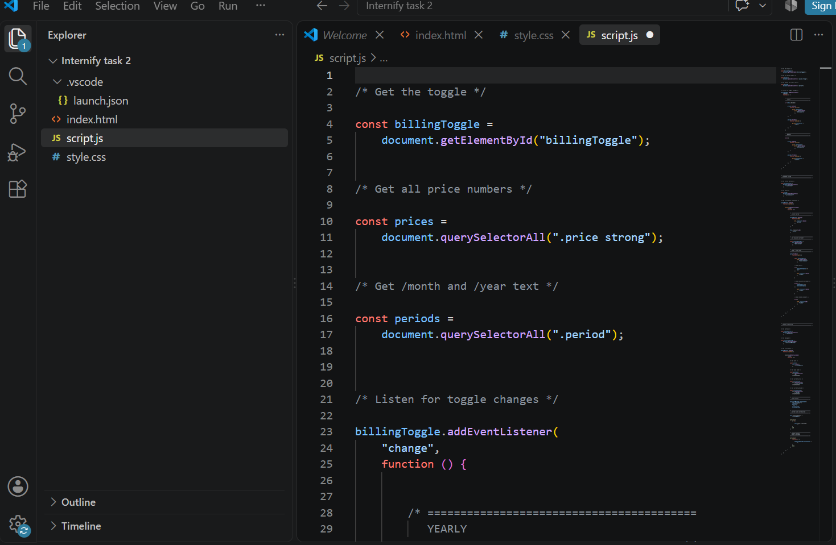

Output:
